ABB Enterprise Analytics Dashboard
Interactive Business Intelligence & Data Visualization Report

Prepared for
ABB Internship Assessment

Prepared by: Jha Piyush
Information Science & Engineering
Dayananda Sagar College of Engineering
June 2026

1.⁠ ⁠Project Overview

The ABB Enterprise Analytics Dashboard is an interactive business intelligence solution developed using Tableau to transform raw organizational data into meaningful insights. The project integrates workforce, salary, security, and system architecture data to provide decision-makers with a comprehensive view of organizational performance through intuitive dashboards.

The solution focuses on presenting complex information in a simple, interactive, and visually appealing manner, enabling users to monitor key metrics, analyze trends, and make informed decisions efficiently.

- ⁠ ⁠Project Objective

The primary objective of this project is to design an interactive analytics dashboard that consolidates organizational data into actionable insights. The dashboard enables stakeholders to monitor employee distribution, salary trends, system security, and infrastructure information while improving accessibility to critical business metrics.

The project also demonstrates the effective use of Tableau for data visualization, dashboard design, and analytical reporting.

- ⁠ ⁠Dataset Description

The project utilizes three structured datasets provided as part of the assessment.

Employee Directory

Contains employee-related information including employee details, department, location, salary, years of experience, and other workforce attributes. This dataset forms the foundation of the Workforce and Salary dashboards.

Access Control Matrix

Contains information related to organizational security, including user access levels (L1, L2, L3), Multi-Factor Authentication (MFA) requirements, audit logging status, and system-level access permissions. This dataset supports security monitoring and compliance analysis.

System Architecture

Contains details about enterprise systems such as hosting environment, system type, data classification, ownership, and infrastructure information. This dataset is used for infrastructure and system analytics.

- ⁠ ⁠Data Preparation

Before visualization, the datasets were reviewed and prepared to ensure consistency and reliability.

The following preprocessing activities were performed:

•⁠ ⁠Verified data consistency across all datasets.
•⁠ ⁠Examined missing and duplicate records.
•⁠ ⁠Standardized field names where required.
•⁠ ⁠Established relationships between relevant datasets using the common System/System Name field.
•⁠ ⁠Created calculated fields for key performance indicators.
•⁠ ⁠Formatted numerical values and salary metrics for improved readability.

These preparation steps ensured accurate analysis and visualization.

5.⁠ ⁠Data Model

The project establishes a logical relationship between the Access Control Matrix and System Architecture datasets using the common System identifier.

Relationship Created:

Access_Control_Matrix.System = System_Architecture.System Name

This relationship enables integrated security and infrastructure analysis while maintaining independent workforce analytics from the Employee Directory dataset.

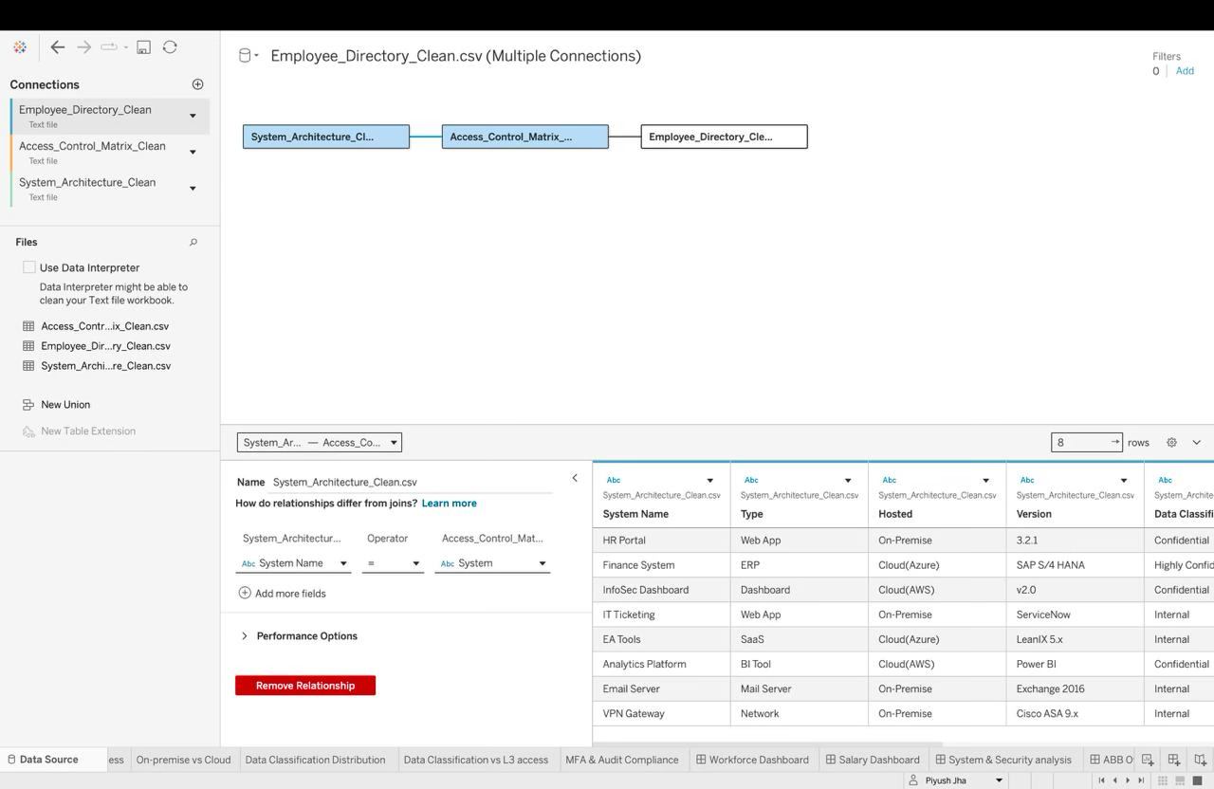
fig 1: Relation between system architecture and access control matrix

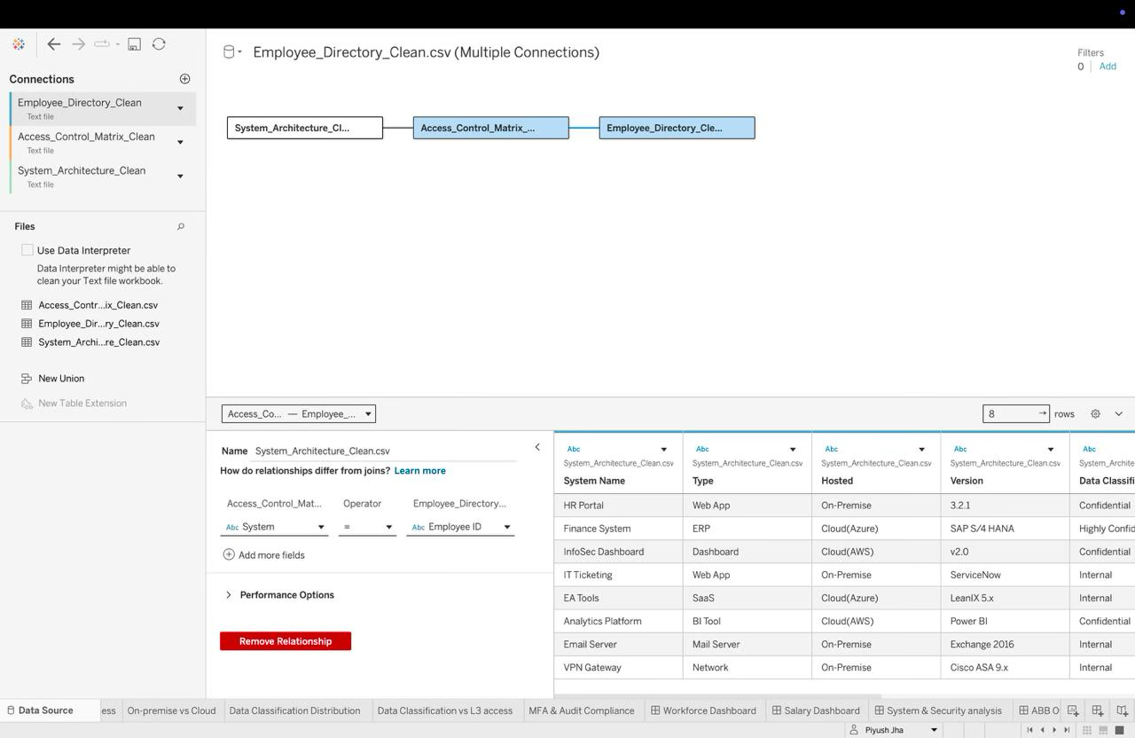
fig 2 : Relation between access control matrix and employee directory

Relationship between the datasets:

The Employee Directory, Access Control Matrix, and System Architecture datasets were connected using Tableau Relationships. The Employee Directory is linked to the Access Control Matrix through the Access Level field, while the Access Control Matrix is linked to the System Architecture through the relevant system/access mapping. This relationship enables combined analysis of employee information, system access permissions, and system architecture for workforce and security reporting.

6.⁠ ⁠Dashboard Summary

The solution consists of four interactive dashboards.

Overview Dashboard

Provides a consolidated summary of the complete analytics solution. It contains high-level KPIs and navigation buttons that allow users to access detailed dashboards efficiently.

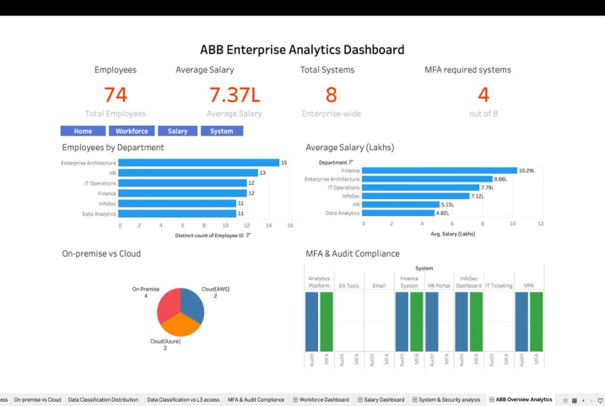
fig 3:Overview Dashboard

Workforce Analytics Dashboard

This dashboard provides insights into workforce distribution across departments and locations. It highlights employee count, departmental distribution, experience levels, and workforce composition to support organizational planning.

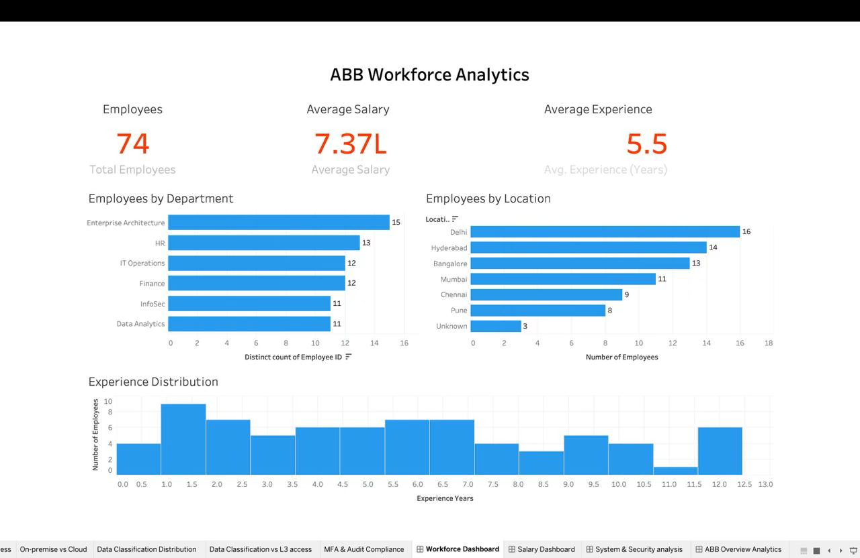
fig 4:Workforce Dashboard

Salary Analytics Dashboard

This dashboard focuses on compensation analysis through salary distributions, departmental salary comparisons, highest and lowest salary indicators, and salary versus experience relationships.

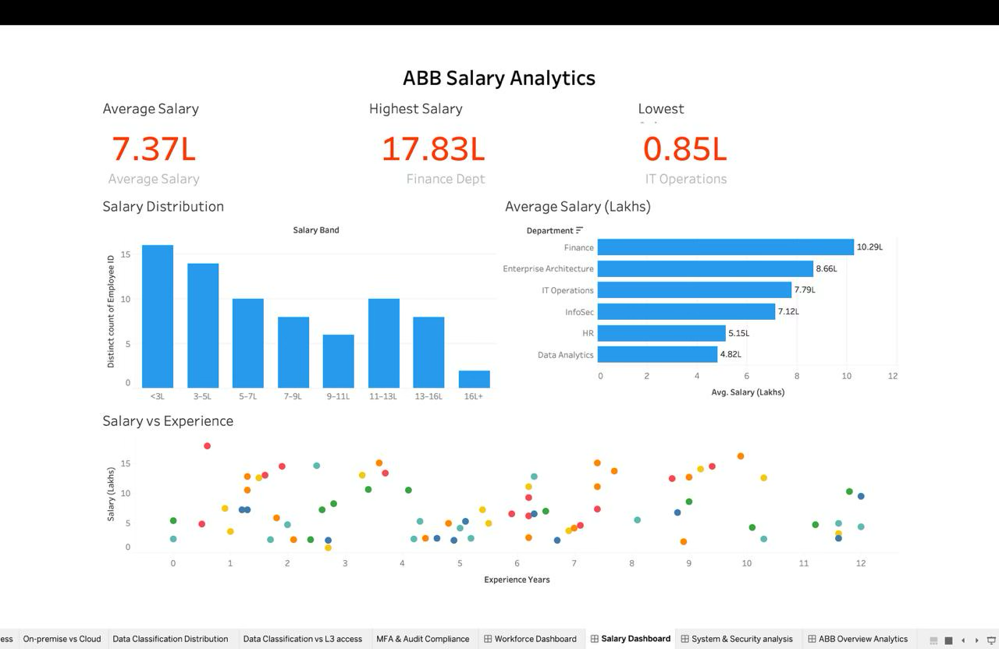
fig 5:Salary Dashboard

Security & System Analytics Dashboard

This dashboard monitors enterprise security and system architecture by presenting KPIs related to total systems, MFA-enabled systems, L3 access, data classification, hosting environment, and security compliance indicators.

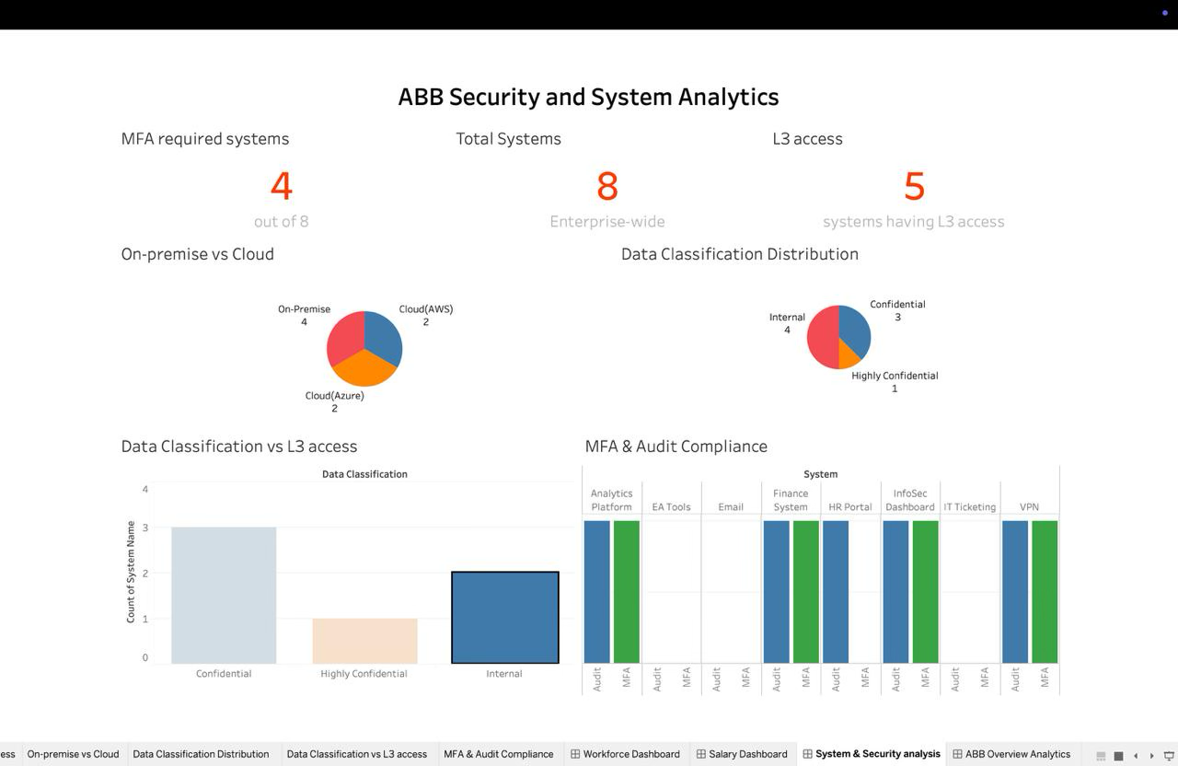
fig 6:Security & System Dashboard

7.⁠ ⁠Key Insights

Workforce Analytics

•⁠ ⁠Employee distribution varies significantly across departments.
•⁠ ⁠Workforce experience differs across organizational units.
•⁠ ⁠Geographic distribution highlights major operational locations.

Salary Analytics

•⁠ ⁠Average salary varies across departments.
•⁠ ⁠Higher experience generally corresponds with higher compensation.
•⁠ ⁠Salary distribution identifies compensation patterns across the organization.

Security & System Analytics

•⁠ ⁠Multi-Factor Authentication has been implemented for selected critical systems.
•⁠ ⁠Systems are distributed across both cloud and on-premise environments.
•⁠ ⁠Data classification identifies systems handling sensitive organizational information.
•⁠ ⁠Security controls such as audit logging and access levels improve compliance visibility.

8.⁠ ⁠Challenges Faced

Several technical and analytical challenges were encountered during development.

•⁠ ⁠Establishing relationships between multiple datasets.
•⁠ ⁠Designing meaningful visualizations using limited source data.
•⁠ ⁠Creating effective KPI cards and calculated fields.
•⁠ ⁠Maintaining a consistent dashboard layout and visual theme.
•⁠ ⁠Optimizing dashboard usability through interactive navigation.

These challenges were addressed through iterative dashboard refinement and visualization optimization.

9.⁠ ⁠Conclusion

The ABB Enterprise Analytics Dashboard successfully transforms organizational datasets into an interactive decision-support solution. The dashboards provide meaningful insights into workforce management, salary analysis, enterprise security, and system architecture through intuitive visualizations.

The project demonstrates practical knowledge of data preparation, relationship modeling, dashboard development, KPI design, and business intelligence reporting using Tableau. The final solution emphasizes clarity, usability, and analytical value, making it suitable for business reporting and executive decision-making.

